First Floor, Ingram Library

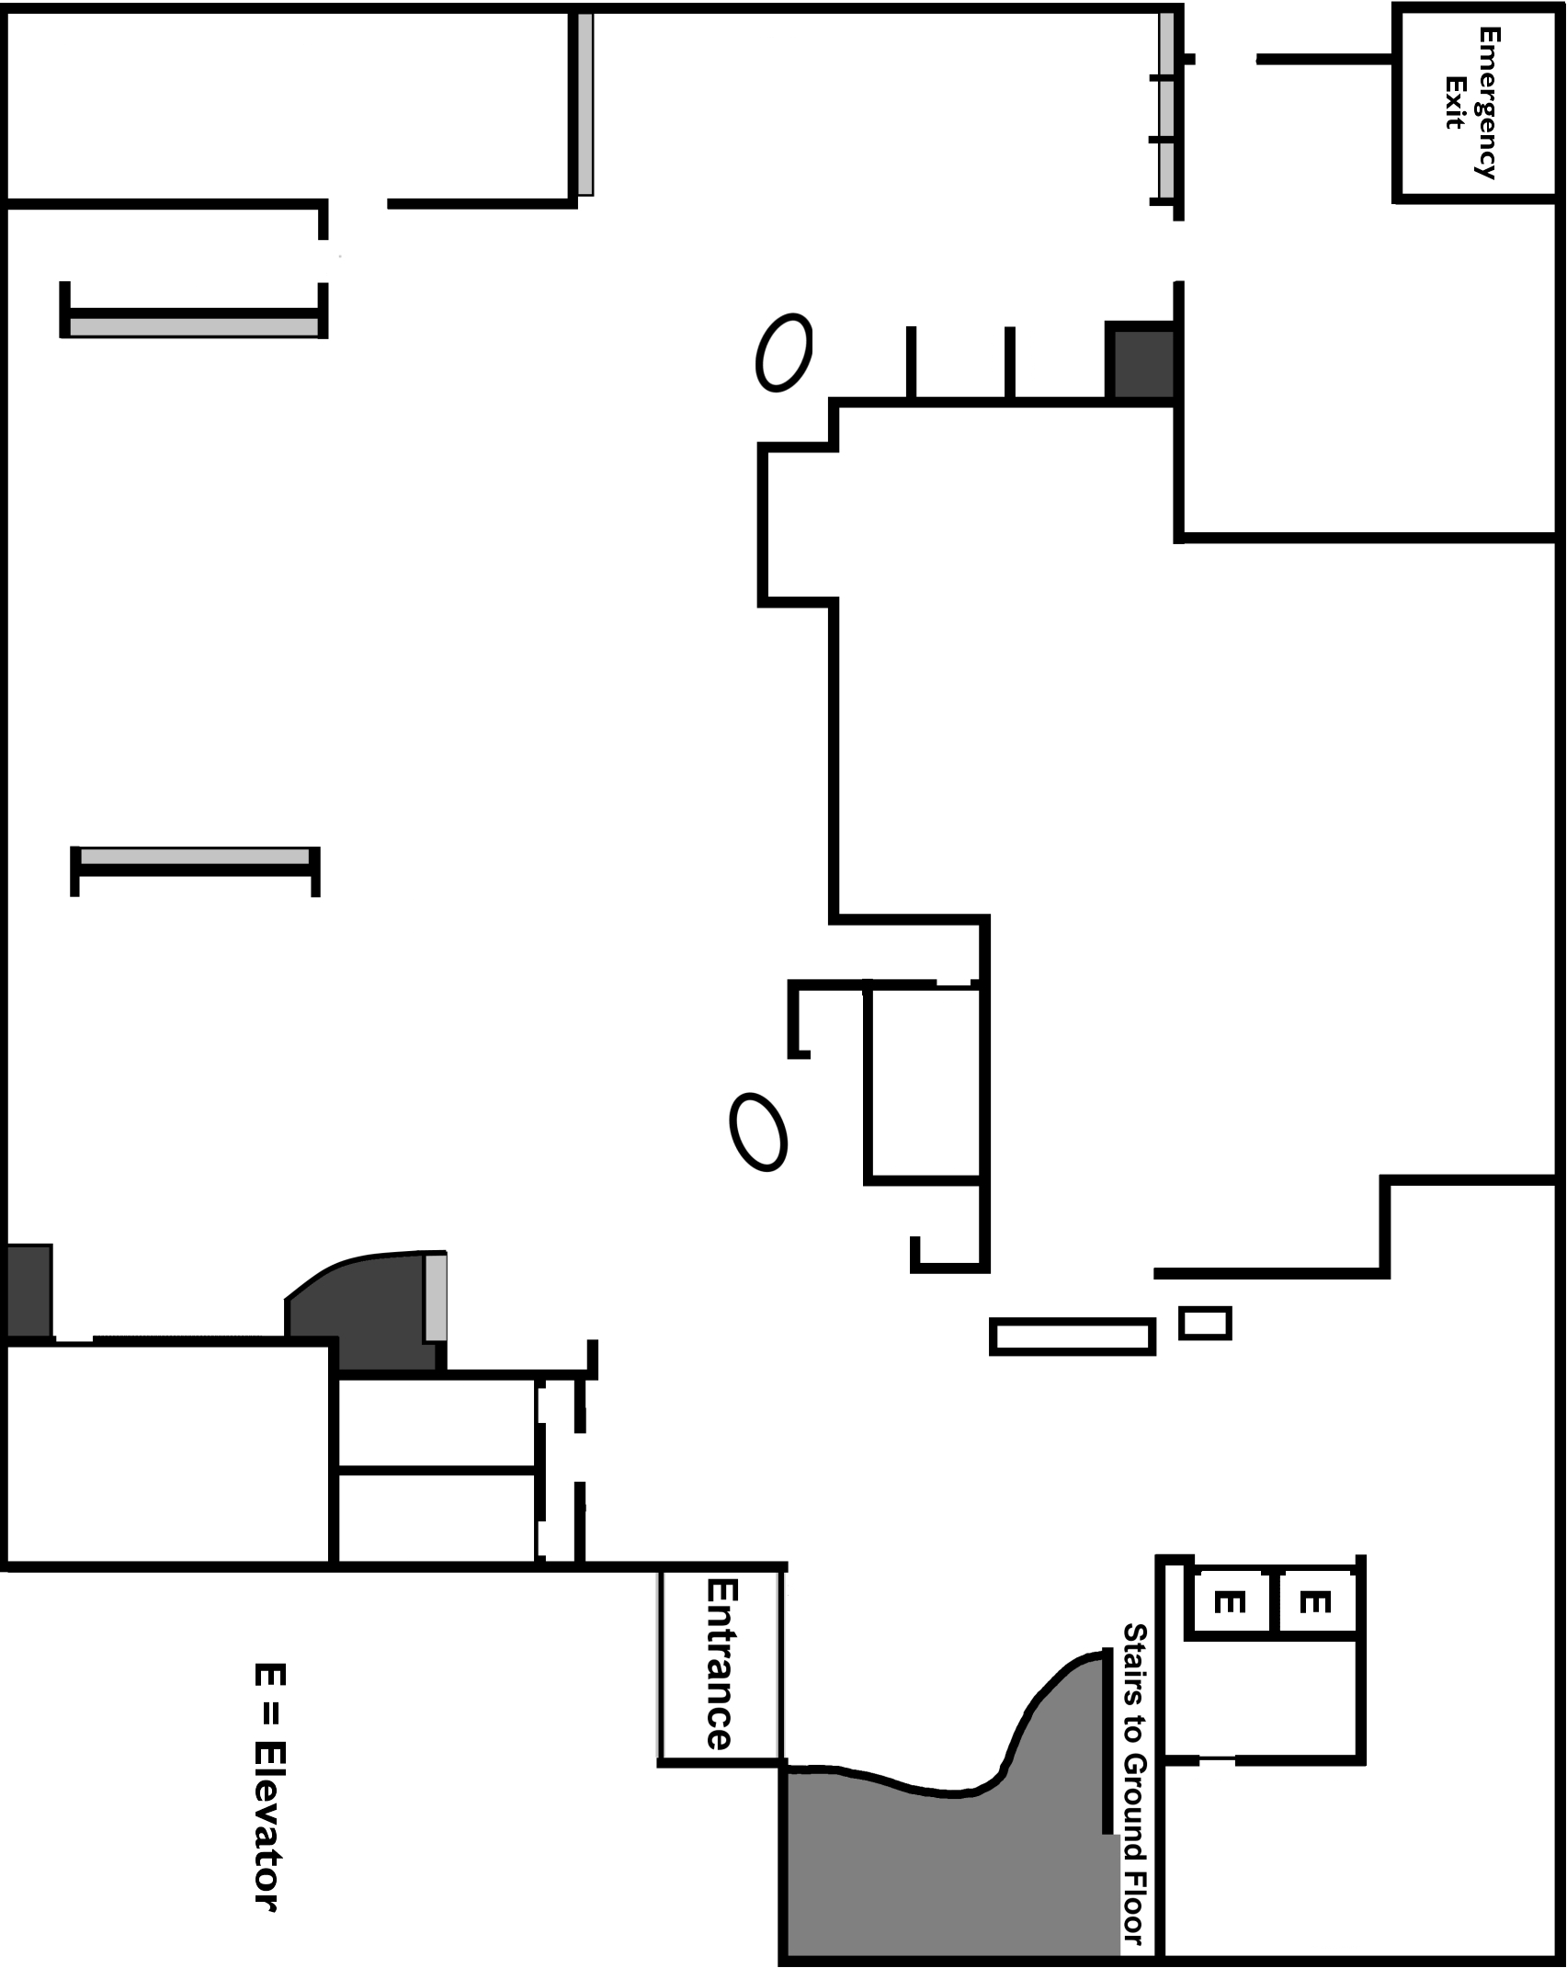

First Floor, Ingram Library

On the map, label or draw:
- Stairs
- Restrooms
- Computers
- Classroom
- Magazine & Newspaper Browsing Area
- DVDs available to check out
- Help Desks
- Check Out Desk (also known as the Circulation Desk)
- Government Documents

Observe how people are using the spaces. Using numbers, label three (3) places you observed people and describe below what those people were doing.

Time and day of observation:

What could you see yourself doing on this floor of the library?

Second Floor, Ingram Library

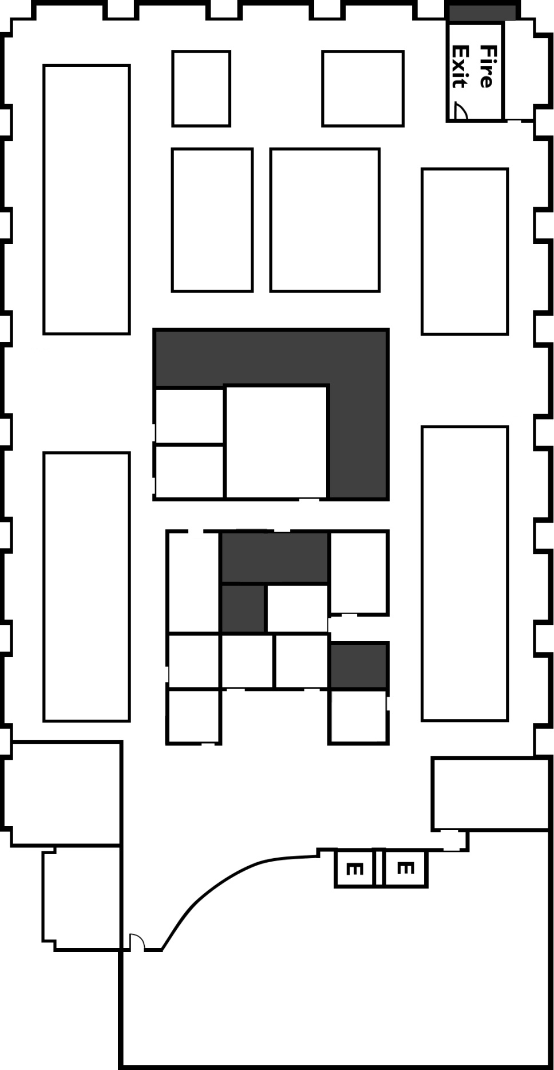
Second Floor, Ingram Library

On the map, label or draw:
- Stairs
- Restrooms
- Computers
- Group Study Rooms
- Holocaust Teacher Education Training and Resource Center

Observe how people are using the spaces. Using numbers, label three (3) places you observed people and describe below what those people were doing.

Time and day of observation:

What could you see yourself doing on this floor of the library?

Third Floor, Ingram Library

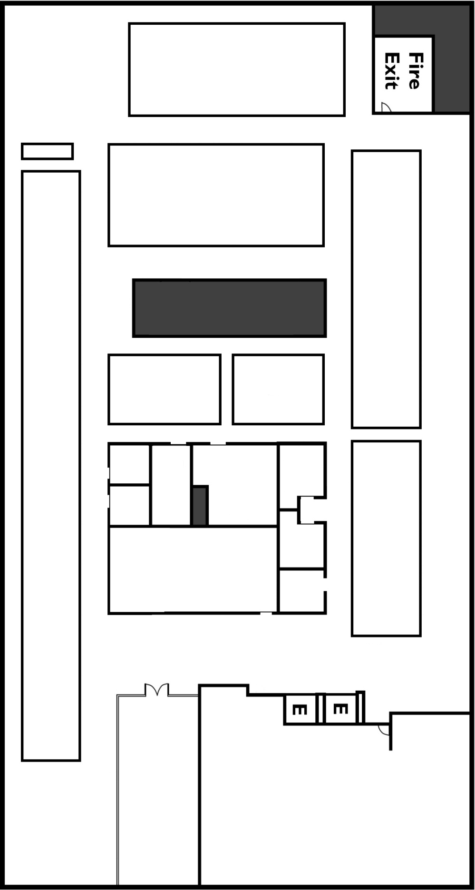
Third Floor, Ingram Library

On the map, label or draw:
- Stairs
- Restrooms
- Computers
- Group Study Rooms
- Classroom
- Quiet Mac Lab

Observe how people are using the spaces. Using numbers, label three (3) places you observed people and describe below what those people were doing.

Time and day of observation:

What could you see yourself doing on this floor of the library?

